CyberRisk Monitor A Lightweight Rule-Based Cybersecurity Monitoring and Risk Assessment Tool

UMGC CMSC 495 – Computer Science Capstone Project Design Document Spring 2026

Team Members: Mustafa Black-Castle, Daniel S. Garrett, Nicholas Porpora, and Cassandra Santacruz

Introduction
This Project Design document presents the execution roadmap for CyberRisk Monitor, a lightweight rule-based cybersecurity monitoring and risk assessment tool developed as part of the UMGC CMSC 495 Computer Science Capstone. The purpose of this document is to translate the approved Project Plan into a structured design and implementation strategy that guides development, scheduling, risk management, and evaluation activities throughout the project lifecycle.
CyberRisk Monitor is designed as a proof-of-concept system rather than a full-scale enterprise solution. The project focuses on analyzing simulated or sample security logs using predefined detection rules to identify indicators of suspicious or potentially malicious activity. The system emphasizes clarity, interpretability, and accessibility, making it suitable for educational environments and small teams seeking an introductory cybersecurity monitoring capability.
This document builds upon the previously established Project Plan by expanding on technical requirements, task decomposition, scheduling logic, and evaluation criteria. It serves as a comprehensive reference for how the project will be executed, monitored, and assessed to ensure alignment with course objectives and successful capstone delivery.

Project Scope
The scope of the CyberRisk Monitor project defines the objectives, deliverables, boundaries, and limitations necessary to ensure successful completion within the fixed academic timeline of the capstone course. The primary objective of the project is to design and implement a functional cybersecurity monitoring tool capable of analyzing structured log data and identifying indicators of suspicious or potentially malicious activity using predefined rules.
The system is developed as a standalone application that operates on simulated or sample security logs rather than real-world production data. This approach avoids legal and ethical concerns while allowing the project team to focus on sound software design, correct implementation of cybersecurity concepts, and meaningful analysis of results. The scope is intentionally constrained to balance realism with feasibility.
In Scope:
- Analysis of simulated or sample security log data for educational and demonstration purposes
- Implementation of approximately 10–15 predefined detection rules that identify basic security patterns
- Basic risk scoring and categorization of findings (Low, Medium, High, Critical)
- Generation of summary dashboards or structured reports that present results clearly
- Support for common structured log formats such as syslog-style text, JSON-formatted data, and CSV files
- A command-line interface and/or a simple graphical interface for user interaction
Out of Scope:
- Real-time monitoring of live network traffic or active systems
- Integration with production or enterprise environments
- Advanced detection techniques such as machine learning or artificial intelligence models
- Automated incident response, blocking, or remediation actions
- Enterprise-scale log aggregation or long-term storage
- Advanced regulatory or compliance frameworks (for example, financial or healthcare compliance standards)

Project requirements
Project requirements for CyberRisk Monitor were derived from capstone course objectives, foundational cybersecurity practices, and the intended educational use of the system. These requirements are designed to ensure that the project demonstrates essential monitoring and risk assessment capabilities while remaining achievable within the project’s time and resource constraints.
A rule-based detection approach was selected instead of machine learning-based methods to prioritize transparency, determinism, and explainability. Rule-based systems allow users to clearly understand why alerts are generated and how risk scores are calculated, which is especially important in an academic context where system behavior must be clearly justified.
Functional Requirements:
- FR-01: The system shall parse security logs provided in syslog-style text, JSON, and CSV formats.
- FR-02: The system shall apply predefined and configurable detection rules to parsed log data.
- FR-03: The system shall identify common security patterns such as repeated failed logins, port scanning behavior, and privilege escalation attempts.
- FR-04: The system shall calculate numerical risk scores for detected events.
- FR-05: The system shall categorize detected risks as Low, Medium, High, or Critical.
- FR-06: The system shall generate summary reports of detected findings.
- FR-07: The system shall present results through a dashboard or structured report interface.
- FR-08: The system shall allow users to adjust detection rule thresholds.
Non-Functional Requirements:
- NFR-01: The system shall process up to 10,000 log entries within 30 seconds on standard consumer hardware.
- NFR-02: The user interface shall be understandable for users with basic technical knowledge.
- NFR-03: The system shall include error handling and internal logging to support debugging.
- NFR-04: The codebase shall be documented and follow consistent coding standards.
Technical Requirements:
- Programming Language: Python 3.10 or later
- Operating System: Cross-platform compatibility (Windows, macOS, Linux)
- Version Control: Git with a shared GitHub repository
- Frameworks and Libraries: Standard Python libraries; optional use of Flask or Streamlit for visualization
- Configuration and Storage: JSON or YAML files for rules; optional lightweight database for persistence

Project Methodology
The CyberRisk Monitor project follows an Agile-inspired development methodology adapted to the structure of the CMSC 495 capstone course. Development activities are organized into short, iterative cycles aligned with weekly course milestones, allowing for incremental progress and regular reassessment of project status.
Each iteration focuses on delivering a functional subset of the system, such as log parsing, rule evaluation, risk scoring, or visualization. Early integration of components is emphasized to reduce technical risk and ensure compatibility across modules. Testing is incorporated throughout development rather than reserved for the final stages.
This methodology balances flexibility with structure, enabling the team to adapt to technical challenges while maintaining a clear and achievable path toward final delivery.

Work Breakdown Structure and Project Tasks
The project work is decomposed into manageable tasks organized by development phase and functional responsibility. This work breakdown structure supports parallel development while maintaining clear dependencies between system components.
Planning and design tasks focus on documentation, architectural decisions, and rule definition. Development tasks address log parsing, rule evaluation, risk scoring, and dashboard creation. Integration and testing tasks ensure that individual modules function correctly as a cohesive system. Documentation and presentation tasks support final project delivery.
Major task phases include planning and design, core development, integration, testing and refinement, and final delivery. Task ownership is distributed across team members based on primary responsibilities while maintaining collaborative accountability.

Project Schedule
The project schedule spans six weeks, corresponding to now Weeks 3 through 8 of the capstone course. Milestones are structured to ensure consistent progress while allocating sufficient time for integration, testing, and refinement.
Foundational components such as log parsing and rule evaluation are scheduled early to support downstream activities such as dashboard development and reporting. The schedule is designed to be realistic within the academic timeframe and supports iterative development and continuous improvement.

Project risks
Cybersecurity projects often involve technical complexity and integration challenges, making proactive risk management essential. Potential risks include limited availability of team members, unfamiliarity with cybersecurity concepts, scope creep, and technical integration issues.
Mitigation strategies include early research, clear scope definition, modular system design, and continuous testing throughout development. These strategies reduce the likelihood of delays and increase the probability of successful project completion.

Project Evaluation Plan
Project success will be evaluated using both qualitative and quantitative criteria. Functional correctness will be assessed by verifying that all defined functional requirements are implemented and operate as intended. Performance benchmarks will be used to confirm that log processing meets non-functional requirements.
Usability will be evaluated based on clarity of system outputs and ease of interaction. Documentation quality, completion of milestones, and readiness for final demonstration will also factor into the overall evaluation. Successful completion of all planned deliverables and a functional system demonstration will constitute project success.

System Design Overview and UML Diagram
CyberRisk Monitor follows a modular system architecture that separates data ingestion, rule evaluation, risk assessment, and presentation. This separation of concerns supports maintainability, testability, and clear responsibility boundaries.
Primary System Components:
- LogParser: Ingests and normalizes log data from multiple input formats
- RuleEngine: Applies detection rules to parsed log entries
- RiskScorer: Calculates risk scores and assigns severity levels
- ReportGenerator: Produces summary reports and visualizations
- UserInterface: Provides user interaction and output display
Conceptual UML Class Diagram:
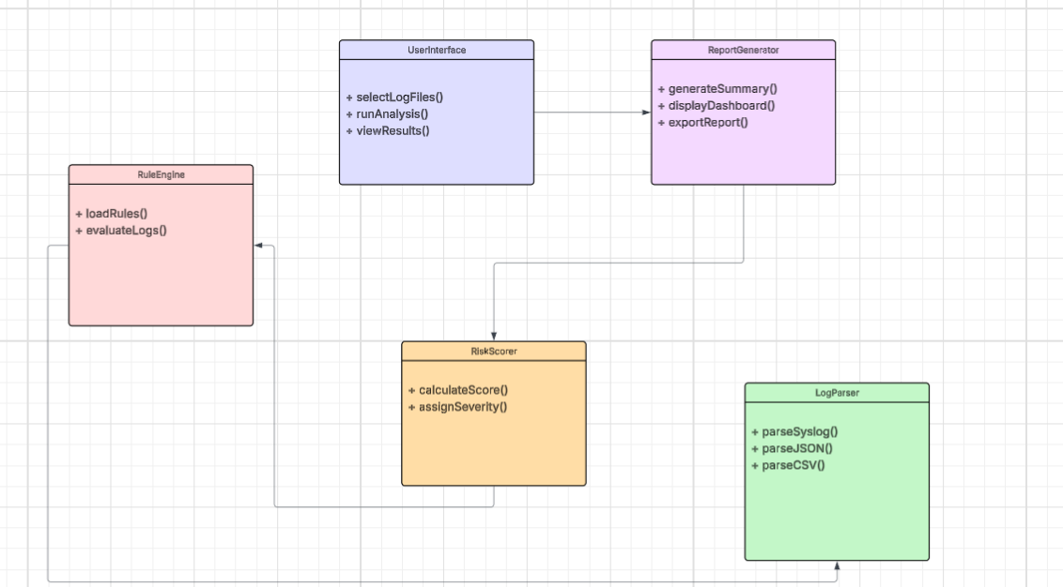
This UML diagram illustrates the logical flow of data through the system. Log data is parsed, evaluated against detection rules, scored for risk, and presented to the user through reports or dashboards. This design supports modular development and simplifies testing and maintenance.

System Architecture Design
CyberRisk Monitor is designed using a modular system architecture that separates core functionality into independent yet cooperative components. This design choice improves maintainability, scalability, and testability by ensuring that each component has a clearly defined responsibility. Modular architecture also reduces system complexity and allows future enhancements to be implemented without significant redesign.
The system is composed of five primary components: LogParser, RuleEngine, RiskScorer, ReportGenerator, and UserInterface. These components are organized in a structured processing pipeline that moves data from ingestion through analysis and finally to presentation. Each component communicates through well-defined interfaces, minimizing coupling and improving system reliability.
The LogParser module ingests raw log files and converts them into a normalized internal data structure. The RuleEngine evaluates each parsed log entry against predefined detection rules. Detected events are passed to the RiskScorer, which assigns numerical scores and severity levels. The ReportGenerator compiles results into structured summaries, which are presented to the user through the UserInterface. This architecture supports incremental development and simplifies debugging, testing, and future expansion.

Data Flow and Processing Logic
The data flow within CyberRisk Monitor follows a deterministic and sequential processing model to ensure consistent and transparent analysis. Processing begins when a user submits one or more log files through the system interface.
The LogParser module first identifies the format of each input file, such as syslog-style text, JSON, or CSV. Parsed log entries are normalized into a unified internal representation, standardizing fields such as timestamps, event types, source addresses, and user identifiers. Normalization ensures that detection rules can be applied uniformly across different log formats.
Normalized log entries are then evaluated by the RuleEngine. Each rule is applied to relevant log entries, and matching conditions generate detection events. These events are forwarded to the RiskScorer, which assigns scores based on severity, frequency, and contextual relevance. Scores are aggregated to determine overall risk levels, which are then passed to the ReportGenerator. The final output is presented to the user through structured reports or dashboards, completing the processing lifecycle.

Rule Design and Risk Scoring Model
CyberRisk Monitor uses a rule-based detection model to identify indicators of suspicious or potentially malicious activity. Detection rules are designed to represent common security patterns observed in system and network environments. Each rule consists of defined conditions, thresholds, and an associated severity value.
Rule conditions may include repeated authentication failures within a specific time window, excessive connection attempts to sequential ports, or abnormal privilege escalation activity. Thresholds determine when normal behavior transitions into suspicious behavior. Severity values reflect the potential impact of each detected pattern.
The risk scoring model aggregates individual rule detections into cumulative risk scores. Events with higher severity or repeated occurrence contribute more significantly to the final score. Aggregated scores are mapped to categorical risk levels such as Low, Medium, High, or Critical to provide an intuitive assessment of system risk. This approach balances analytical accuracy with usability and interpretability.

Future Enhancements
Although CyberRisk Monitor is implemented as a proof-of-concept system, its modular architecture supports future expansion. Potential enhancements include real-time log ingestion, automated alerting mechanisms, and integration with live systems. The addition of machine learning-based anomaly detection could further enhance detection accuracy by identifying novel threat patterns.
Additional improvements may include expanded visualization dashboards, role-based access control, and integration with established security information and event management (SIEM) platforms. These enhancements would increase the system’s applicability in professional environments while building upon the existing design foundation.

Testing and Validation Strategy
Testing and validation are conducted throughout the development lifecycle of CyberRisk Monitor to ensure functional correctness, reliability, and alignment with project requirements. A structured testing approach is used to verify that individual components operate correctly both in isolation and as part of the integrated system.
Unit testing is applied to core modules, including the LogParser, RuleEngine, and RiskScorer components. These tests validate correct parsing of supported log formats, accurate application of detection rules, and proper calculation of risk scores. Unit tests are designed to confirm expected behavior under normal operating conditions and to identify defects early in development.
Integration testing focuses on validating interactions between system components. End-to-end test cases are executed using simulated log datasets to ensure that data flows correctly from ingestion through rule evaluation, risk scoring, and report generation. These tests confirm that the system produces consistent and accurate results when processing complete log files.
Validation testing is performed to assess the system’s ability to meet defined functional and non-functional requirements. Functional validation verifies that all specified detection rules operate as intended and that identified events are correctly categorized into risk levels. Non-functional validation evaluates system performance by confirming that the system can process up to 10,000 log entries within the specified time constraints on standard consumer hardware.
Additional testing includes handling of edge cases such as empty log files, malformed entries, and unsupported input formats. These tests ensure that the system fails gracefully and provides meaningful error messages without compromising stability. Testing results are documented and used to guide refinement prior to final demonstration and submission.

Conclusion
This Project Design document provides a comprehensive roadmap for the successful execution of the CyberRisk Monitor capstone project. By defining clear scope boundaries, system requirements, development methodology, task structure, scheduling, risk management strategies, and evaluation criteria, the project establishes a realistic and achievable implementation plan. Successful completion of this design and its associated implementation will demonstrate my team’s ability to apply computer science principles in a structured, real-world context. CyberRisk Monitor serves as both a functional monitoring prototype and an educational tool, reinforcing core concepts such as log analysis, rule-based detection, and risk assessment. This design establishes a clear foundation for development, testing, and final demonstration in fulfillment of the CMSC 495 capstone requirements.

